Paper Title (16 Bold)

Author (14)
¹(AOI, Cairo, Egypt (10)
Corresponding Author: xxxx (10)

ABSTRACT :(10 Bold) The widespread application of renewable energy systems requires the use of data acquisition units both for monitoring system operation and control of its operation. In this paper, the topologies for the monitoring system – including remote monitoring – for both solar and wind energies are presented. This feature is essential in renewable energy plants since they are usually installed in inaccessible or remote areas. The measured parameters are available on-line over the Internet to any user.
KEYWORDS (10) Bold data,monitoring,remote monitoring, solar, wind.
---------------------------------------------------------------------------------------------------------------------------------------
Date of Submission: xx-xx-xxxx Date of acceptance: xx-xx-xxxx
---------------------------------------------------------------------------------------------------------------------------------------

INTRODUCTION (10 BOLD)
Rationalizing an investment in a facility's infrastructure can be a difficult prospect for any plant engineer or technician, often requiring extensive justification. Investments that are deemed “low-risk” by upper management and have a fast return on investment (ROI) are typically the easiest to substantiate. One such investment that will pay considerable dividends over the course of its operating life is a comprehensive power monitoring system.Even though increased energy prices have become a larger influence on the balance sheet, many facilities do not take advantage of opportunities to better manage these expenses. Those without monitoring systems likely have no understanding of their energy usage; those with them may not be using their systems to the fullest potential.
Because the quality of energy supplied can adversely affect its operation, oftentimes leading to loss or degradation of equipment, product, revenue, and reputation, plant managers must weigh the advantages of implementing a monitoring program.
The second section of this paper shows three methods for monitoring systems of solar plants. The third section discusses communication and monitoring system for wind turbines, and finally the conclusion is discussed in the fourth section.

SOLAR PLANTS MONITORING SYSTEM (10 BOLD)

Variations in solar radiation at a site can dramatically affect energy yields from solar generation facilities.Accurate assessments of solar power resources at a potential site can support planning and provide information that ensures optimum solar power yield which assist maximizingthe return on investment in solar energy.

The main objectives of monitoring solar energy resources:
- Determine the actual potential energy yield.
- Identify ideal locations for solar power stations and panels.
- Optimize placement to maximize efficiency.
- Monitor system performance over time.
- Analyze errors and their causes.

Fig.1 shows the simple way to monitor a solar PV (photovoltaic) plant; the system mainly consists of a set of sensors for measuring both meteorological (e.g. temperature, radiation, wind speed etc.) and electrical parameters (photovoltaics voltage and current etc.). The collected data are first conditioned using precision electronic circuits and then interfaced to a PC using a data-loggerunit. The inverter(s) of the solar plant are also interfaced to the data-logger unit through communications methods; most commonly RS485 serial interface.
The system is capable of performing real-time measurement of electrical data that can be effectively transferred to a remote monitoring center via the internet.
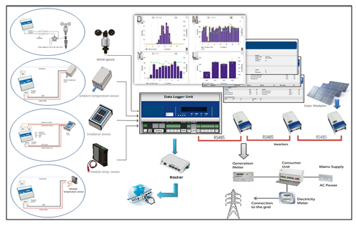
Fig.1. Data-logger unit for monitoring solar PV plants

The results from the above system are given in both tabulated and graphical forms. Daily, monthly, yearly and total plant production are the main output parameters from the system in addition to carbon dioxide (Co2) saving and system data. Some results are shown in Fig. 2.

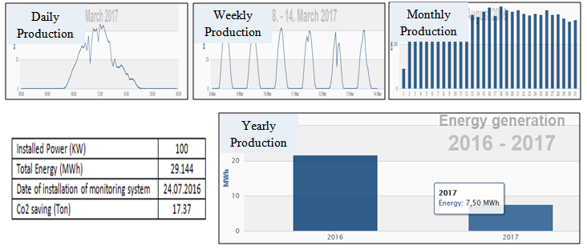
Fig. 2. PV solar plant data
Another method for PV monitoring is to use an IP router (Ex. Linksys) as shown in fig. 2. In this method a virtual private network (VPN) is created through the configuration of the Linksys to enable monitoring of the PV solar system via internet.

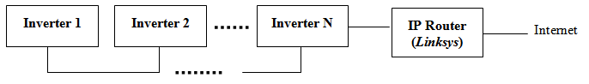
Fig. 3.Second method for PV monitoring system

The third topology that can be used for PV monitoring system is the web based server with a SCADA (Supervisory control and data acquisition) system implemented to monitor the parameters of the system and giving alarms in case of errors occurred. Fig. 4 shows an example of such network.Fig. 5 shows sample of the results of the system for real time data, historical data and alarms.

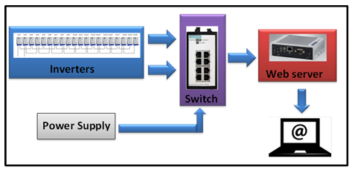
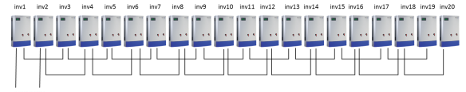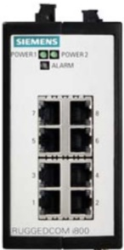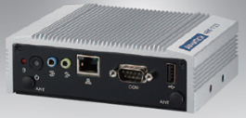Fig. 4. Third method for PV monitoring system
Inverters
Switch
Power Supply
Web server
Inverters
Switch
Power Supply
Web server
Monitoring System Block diagram

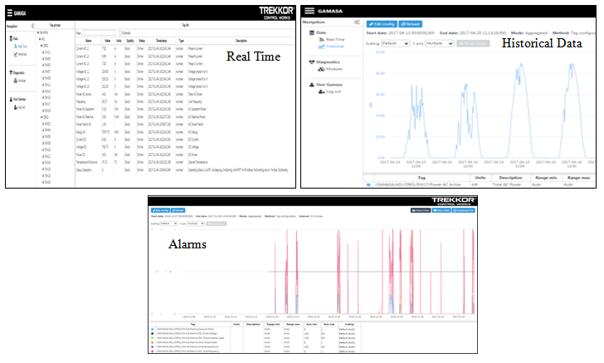
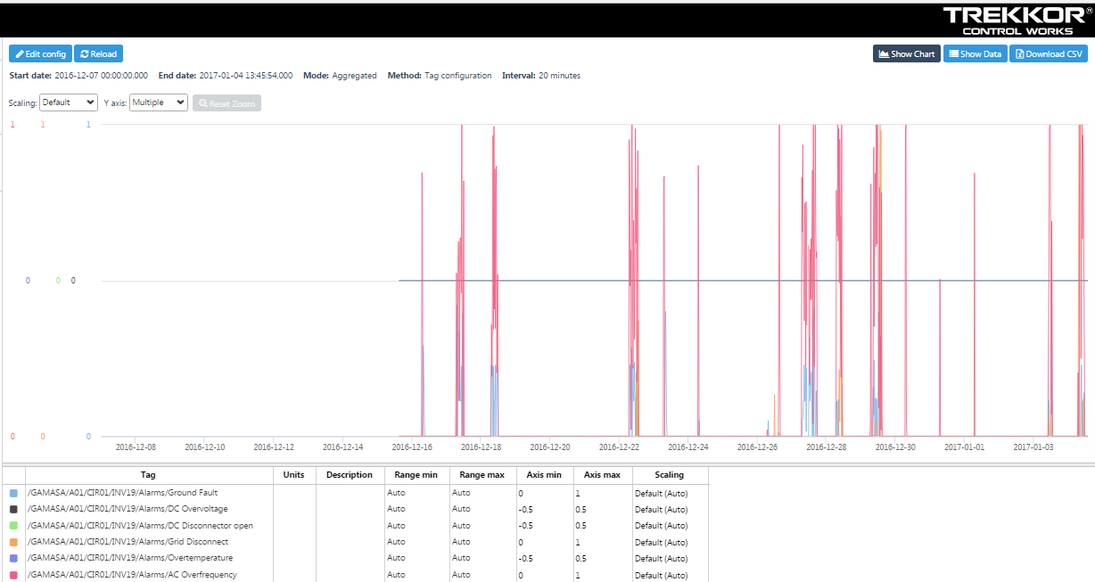
Fig. 5.Real time, historical data and alarms

- WIND TURBINES MONITORING SYSTEM (10 BOLD)
Monitoring systems can anticipate failures and allow turbine owners to schedule for repairs in addition to the regular maintenance of the turbines. In addition to monitoring the turbine parameters it is possible to control the wind turbines as stating, stopping and reset can be performed from the control room in the site and also remotely in case of need. Fig. 6 shows a block diagram for monitoring system of wind turbines and samples of the results are shown in fig.7.

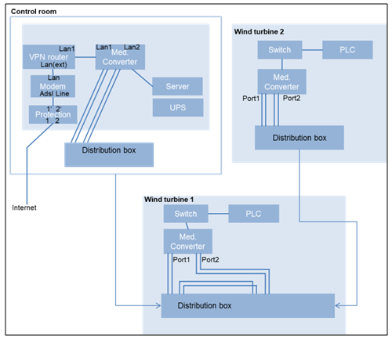
Fig. 6.Wind turbine monitoring system

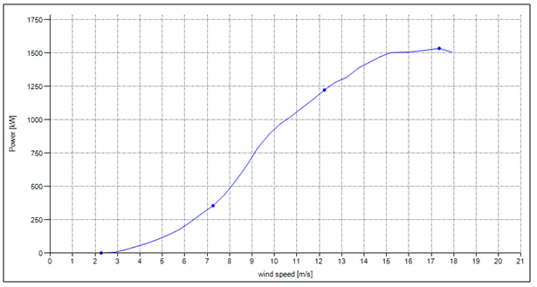

Power Curve
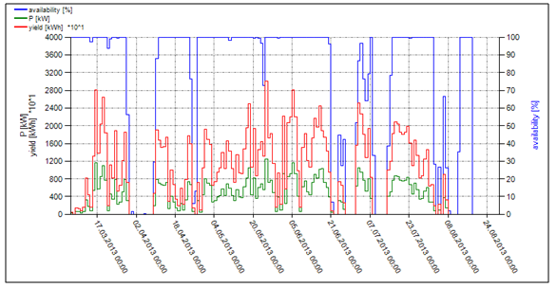
Fig. 7. Wind turbine monitoring system results

CONCLUSION (10 BOLD)
There are many benefits to installing a monitoring system — some of which strongly interrelate with each other. A properly designed and installed monitoring system offers a deeper understanding of the operational parameters of the system. A close appraisal of the data generated by a monitoring system can reveal a variety of overt and subtle opportunities, including:
Environmental —better knowledge of how energy is used allows you to identify an array of prospects to improve efficiencyand reduce energy consumption.
Reliability — assessment of data from the monitoring system can reveal existing or imminent issues that can adversely affect the operation and product within a facility. Historical data from monitoring systems can help locate and correct both acute and chronic problems, resulting in increased productivity.
Maintenance — Data trends can forecast and notify the appropriate people when discrete equipment parameters may be exceeded, allowing you to plan ahead instead of facing an unscheduled shutdown.
Financial — each benefit discussed above either directly or indirectly influences a business's bottom line. In most cases, the monetary impact from even one or two benefits can quickly justify the purchase and installation of a monitoring system.

REFERENCES (10 BOLD)
- IEA: World Energy Outlook 2009. International Energy Agency Publications (2008).
- Benghanem, M., Maafi, A.: Data Acquisition System for Photovoltaic Systems Performance Monitoring. IEEE Transactions on Instrumentation and Measurement 47, 30–33 (1998).
- Forero, N., Hernández, J., Gordillo, G.: Development of a monitoring system for a PV solar plant. Energy Conversion and Management 47(15-16), 2329–2336 (2006).
- Jorge, A., Guerreiro, J., Pereira, P., Martins, J., Gomes, L.: Energy Consumption Monitoring System for Large Complexes. In: Camarinha-Matos, L.M., Pereira, P., Ribeiro, L. (eds.) DoCEIS 2010. IFIP AICT, vol. 314, pp. 22–24. Springer, Heidelberg (2010).

